**Blue Green Vs Canary Deployment**

**Introduction:**

In software delivery, there are different deployment strategies that can be used for deploying any applications. Implementing the right deployment strategy is a critical part of a complete and well-functioning deployment.

**BLUE GREEN DEPLOYMENT:**

**Definition:** Blue green deployment is an application release model that gradually transfers user traffic from a previous version of an app or micro service to a nearly identical new release—both of which are running in production.

* In this strategy, we create two separate, but identical environments.
* One environment (blue) is running the current application version and one environment (green) is running the new application version.
* The usage of a blue/green deployment approach increases application availability and decreases deployment hazard by simplifying the rollback method if a deployment fails.
* Once testing has been completed on the green environment, live application traffic is directed to the green environment and the blue environment is deprecated.

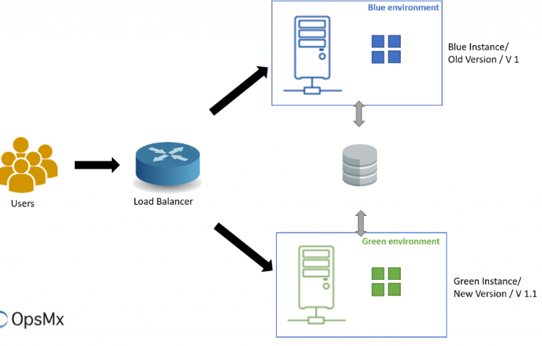

**The Benefits of implementing Blue-Green deployments:**

* **Seamless consumer experience:** customers don’t revel in any downtime.
* **Instant rollbacks**: We can undo the change without adverse effects and go back to the previous best state.
* **No upgrade-time schedules for developers**: Need not wait for low traffic windows to deploy the updates.

**Challenges:**

* **High infrastructure costs**: Organizations that have adopted a Blue-Green strategy need to maintain an infrastructure that doubles the size required by their application.

##### **Code compatibility**: Developers need to ensure that each new update is compatible with the previous environment.

**CANARY DEPLOYMENT:**

**Definition**: A canary deployment, or canary launch, is a deployment sample that permits you to roll out new code/capabilities to a subset of customers as an initial take a look at.

* It is the practice of making staged releases.
* We roll out a software program replace to a small a part of the customers first, so they will check it and provide remarks.
* Once the change is accepted, the replace is rolled out to the rest of the users
* Canary deployments show us how users engage with utility changes in the actual world.

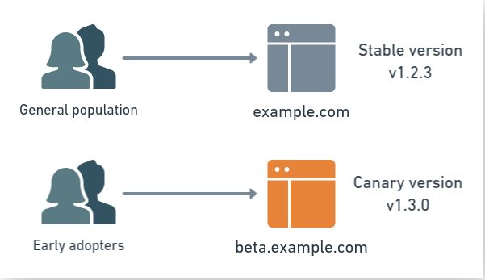

## Benefits of Canary Deployments

## A/B testing: we can use the canary to do A/B testing. In different words, we present two alternatives to the users and see which gets better reception.

* **Feedback**: we get crucial input from real users.

**Challenges**

* **Frustration**: The first group using the canary will find the worst bugs.
* **Complexity**: Canary deployments share the same complexities as blue-green deployments - having many production machines, migrating users, and monitoring the new system.

**Comparison- Blue Green Vs Canary Deployments:**

* Blue Green Deployment would be the best choice when the code is thoroughly tested, the chance of failure is low, and there is a need to switch all users at once.
* Canary is probably a better choice when there is low-to-decent chance of failure, when an experimental feature is implemented.